# 

# Department of Computing

**CS-344: Web Engineering**

**Class:** BESE-9AB

# Lab 07: JavaScript

**Date: November 26, 2020**

# Instructor: Dr. Qaiser Riaz

# 

**Ahmed Hassan Ismail – BESE-9B – 237897**

# Lab 07: JavaScript

### Introduction:

JavaScript is a well-known scripting language which is widely used to handle behavior of a web site. Most of modern websites use JavaScript and JavaScript based frameworks to control dynamic behavior at the client side. Students have learned basic concepts of JavaScript during lectures. This lab will help them to get practical knowledge of JavaScript.

### Lab Objectives:

The objective of this lab is helping students to familiarize themselves with basic concepts of JavaScript by practically implementing them in a given situation. The knowledge, students have gained in the lectures will help students to develop and control dynamic behavior of a web page using JavaScript.

### Tools:

Notepad, browser.

### Helping Material:

Lecture slides.

W3Schools: <https://www.w3schools.com/js/default.asp>

### Lab Task

### Task 1

Create a simple web based calculator as shown in the image below.

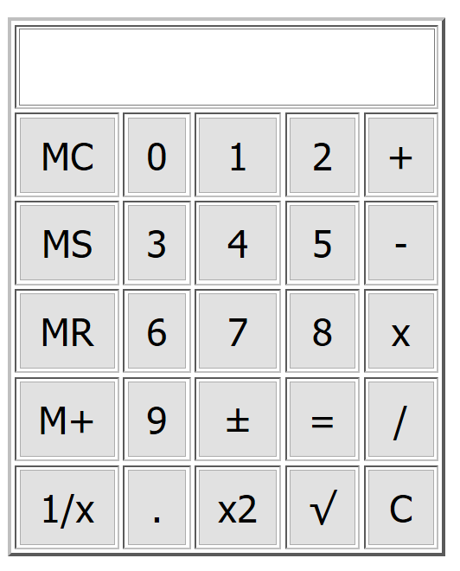

Following are the important functionalities of the calculator:

1. Whenever a user presses any number (0-9) or operations (+,-,x,/,±, .), it must be shown in the input text field (see example image below).

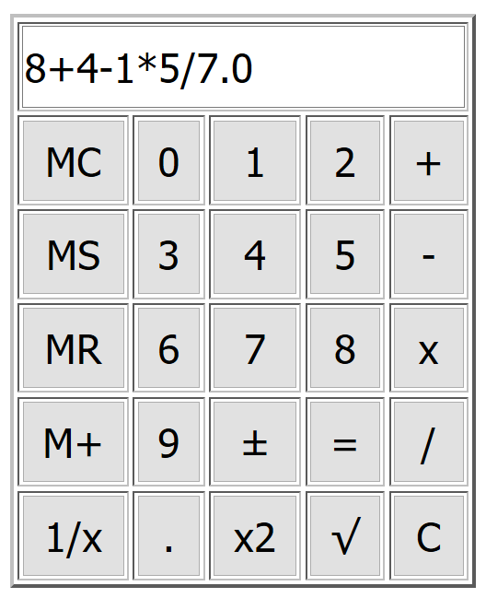

1. In case of ‘.’ button pressed, a ‘0’ must be added at the end of the string as shown in above image.
2. When ‘=’ button is pressed result is shown in the text field.
3. ‘C’ button must clear and reset everything (text field, any storage variables).
4. For a given input N, ‘1/x’ should give the results of 1/N (e.g. input =5, result = 0.20) of the given input.
5. For a given input N, ‘x2’ should square the input (e.g. input =5, result = 25).
6. The square root button, ,should calculate the square root of the input.
7. The ‘±’ button should add/remove a ‘–’ sign to the input value.
8. MS button must store the numeric input value written in the text field in a variable. In case of an equation as shown in the image above, it should not store anything.
9. MC button should clear stored numeric value.
10. MR button should recall the stored value and display it in the input text field.
11. M+ button should add the input value given in the text field in to the stored value in memory and save it as stored value.

**Hints:**

1. JS ‘OnClick’ event will be attached to all buttons in the calculator.
2. To handle value storage (MS, MC, MR, M+), create a global variable, M, and change its value according to the button pressed.
3. To display inputs as a sequence of numbers and arithmetic operation (e.g. 2+3-5+7/2.5), use string concatenation.
4. You can use JS eval() function to directly execute a string as a JS statement. See example below:

var input= “2+3-5+2.5/2.5”;

eval(input); // output: 1.0

1. Keep in mind point 4 on eval(), when “=” button is pressed just call var result = eval(document.getElementByID(“inputTextField”).value);
2. In case of any questions, take help from your lab engineer.

**Note: Create a single file with HTML, CSS, and JavaScript and paste a few screenshots of your solution in the box below.**

|  |
| --- |
| Solution |
| Task 1 Screenshots:    Task 1 (HTML, CSS, JS):  <!DOCTYPE html>  <html>  <head>      <title>Ahmed Hassan Ismail - BESE-9B - 237897 - Web Lab 7</title>      <meta name="viewport" content="width=device-width, initial-scale=1">      <!-- <link rel="stylesheet" type="text/css" media="screen" href="app.css" /> -->      <!-- <script src="app.js"></script> -->      <link href="https://fonts.googleapis.com/css?family=Indie+Flower" rel="stylesheet">      <style>          body {              font-family: 'Indie Flower', cursive;          }            .container {              background-color: grey;              height: 250px;              width: 300px;              margin-left: auto;              margin-right: auto;              margin-top: 5rem;              border-width: 10px;              border-color: black;              border-style: solid;              display: table;          }            h5 {              margin: 0;              margin-top: 0.5em;              text-align: center;          }            button {              padding: auto;              width: 55px;              height: 30px;              background-color: black;              color: white;              font-family: 'Indie Flower', cursive;              font-size: 18px;          }            button:hover {              background-color: white;              color: black;          }            button:active {              background-color: red;          }            #calculator {              border-width: 2px;              border-color: black;              width: 100%;          }            #screen {              width: 100%;              height: 30px;              display: block;              margin: auto;              font-family: 'Indie Flower', cursive;          }            #div_screen {              margin: auto;              padding: 5px;          }            #screen {              font-size: 24px;              color: blue;          }            @media only screen and (max-width: 600px) {              table {                  width: 100%;                  margin: 5px;              }              table td {                  display: block;                  width: 100%;              }          }      </style>  </head>  <body>      <div class="container">          <div style="margin:0">              <h5>Casio</h5>          </div>          <div id="div_screen">              <input type="text" id="screen">          </div>          <table id="calculator">              <tr id="second">                  <td><button id="MC" onclick="clear_stored_value()">MC</button></td>                  <td><button id="b0" onclick="buttonShown(0)">0</button></td>                  <td><button id="b1" onclick="buttonShown(1)">1</button></td>                  <td><button id="b2" onclick="buttonShown(2)">2</button></td>                  <td><button id="bplus" onclick="buttonShown('+')">+</button></td>              </tr>              <tr>                  <td><button id="ms" onclick="value_store()">MS</button></td>                  <td><button id="b3" onclick="buttonShown(3)">3</button></td>                  <td><button id="b4" onclick="buttonShown(4)">4</button></td>                  <td><button id="b5" onclick="buttonShown(5)">5</button></td>                  <td><button id="bminus" onclick="buttonShown('-')">-</button></td>              </tr>              <tr>                  <td><button id="mr" onclick="display_stored_value()">MR</button></td>                  <td><button id="b6" onclick="buttonShown(6)">6</button></td>                  <td><button id="b7" onclick="buttonShown(7)">7</button></td>                  <td><button id="b8" onclick="buttonShown(8)">8</button></td>                  <td><button id="bmultiply" onclick="buttonShown('*')">X</button></td>              </tr>              <tr>                  <td><button id="mplus" onclick="mPlus()">M+</button></td>                  <td><button id="b9" onclick="buttonShown(9)">9</button></td>                  <td><button id="bplusminus" onclick="remove_add_negative_sign()">+_</button></td>                  <td><button id="bequalto" onclick="equalTo()">=</button></td>                  <td><button id="bdivide" onclick="buttonShown('/')">/</button></td>              </tr>              <tr>                  <td><button id="oneoverx" onclick="oneOverX()">1/x</button></td>                  <td><button id="bdot" onclick="buttonShown('.')">.</button></td>                  <td><button id="bsquare" onclick="square()">x2</button></td>                  <td><button id="bsquareroot" onclick="squareRoot()">root</button></td>                  <td><button id="bcancel" onclick="reset()">C</button></td>              </tr>          </table>      </div>      <script>          var storedValue;          function buttonShown(value) {              var screen = document.getElementById("screen");              if (value == '.') {                  if (screen.value.indexOf(".") == -1) {                      screen.value += value;                      screen.value += '';                  } else {}              } else {                  screen.value += value;              }          }          function equalTo() {              var text = document.getElementById("screen").value;              var calCulatedText = eval(text);              document.getElementById("screen").value = calCulatedText;          }          function reset() {              document.getElementById("screen").value = "";          }          function oneOverX() {              var text = document.getElementById("screen").value;              var calculatedText = 1 / Number(text);              document.getElementById("screen").value = calculatedText;          }          function squareRoot() {              var text = document.getElementById("screen").value;              var calculatedText = Math.sqrt(Number(text));              document.getElementById("screen").value = calculatedText;          }          function remove_add_negative_sign() {              var text = document.getElementById("screen").value;              var negative = text.charAt(0);              if (negative == "-") {                  var substr = text.substring(1);                  document.getElementById("screen").value = substr;              } else {                  text = "-" + text;                  document.getElementById("screen").value = text;              }          }          function value_store() {              var value = document.getElementById("screen").value;              this.storedValue = value;          }          function display_stored_value() {              var screen = document.getElementById("screen");              var text = screen.value;              text += storedValue;              screen.value = text;              document.getElementById("screen").value = screen.value;          }          function mPlus() {              this.storedValue = (Number(document.getElementById("screen").value) + Number(this.storedValue));              document.getElementById("screen").value = storedValue;          }          function clear_stored_value() {              this.storedValue = "";              document.getElementById("screen").value = storedValue;          }          function square() {              var text = document.getElementById("screen").value;              var calculatedText = Math.pow(Number(text), 2);              document.getElementById("screen").value = calculatedText;          }      </script>  </body>  </html> |

### Deliverables

Compile a single word document by filling in the solution part and submit this Word file on LMS. You must include your name, ID, and class on first page. The lab grading policy is as follows: The lab is graded between 0 to 10 marks. For some of the labs, students have to present their solutions in a viva session. In case of any problems with submissions on LMS, you should contact your lab engineer Mr. Aftab Hussain by email at [aftab.hussain1@seecs.edu.pk](mailto:aftab.hussain1@seecs.edu.pk).